Assignment 1:

Part1:

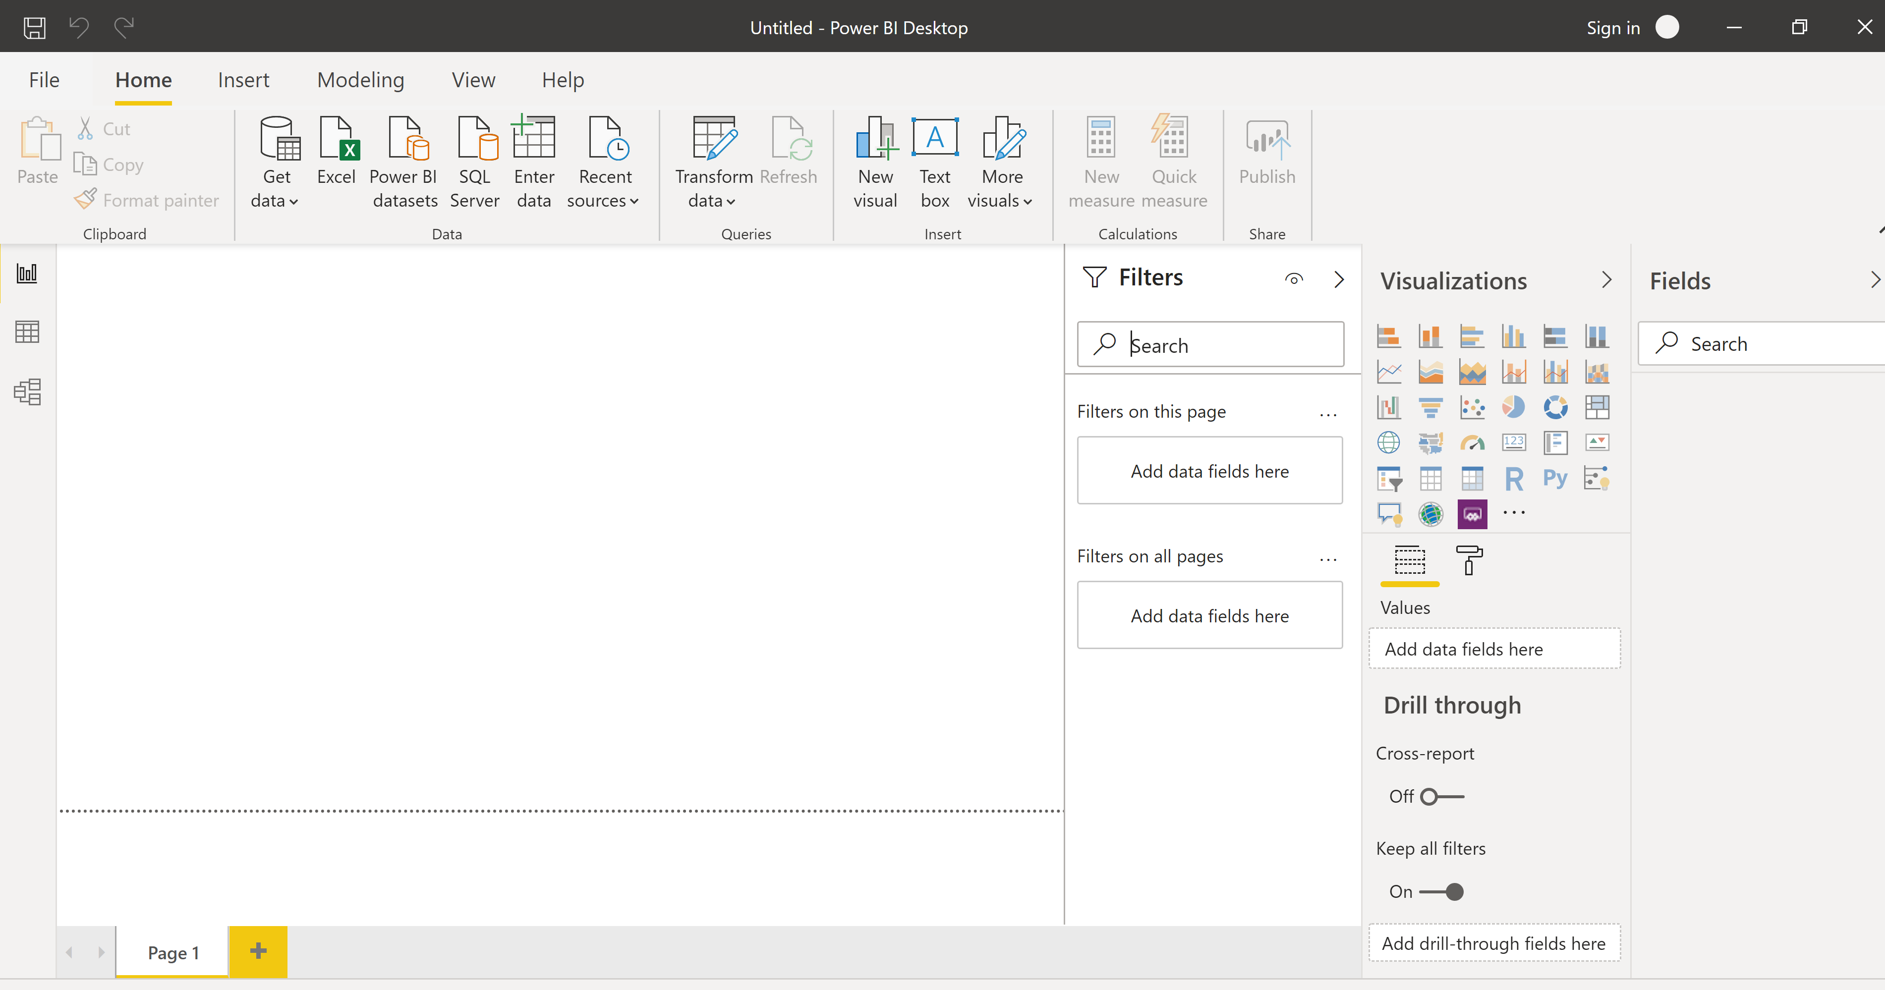

Part 2:

Report View:



Data View:

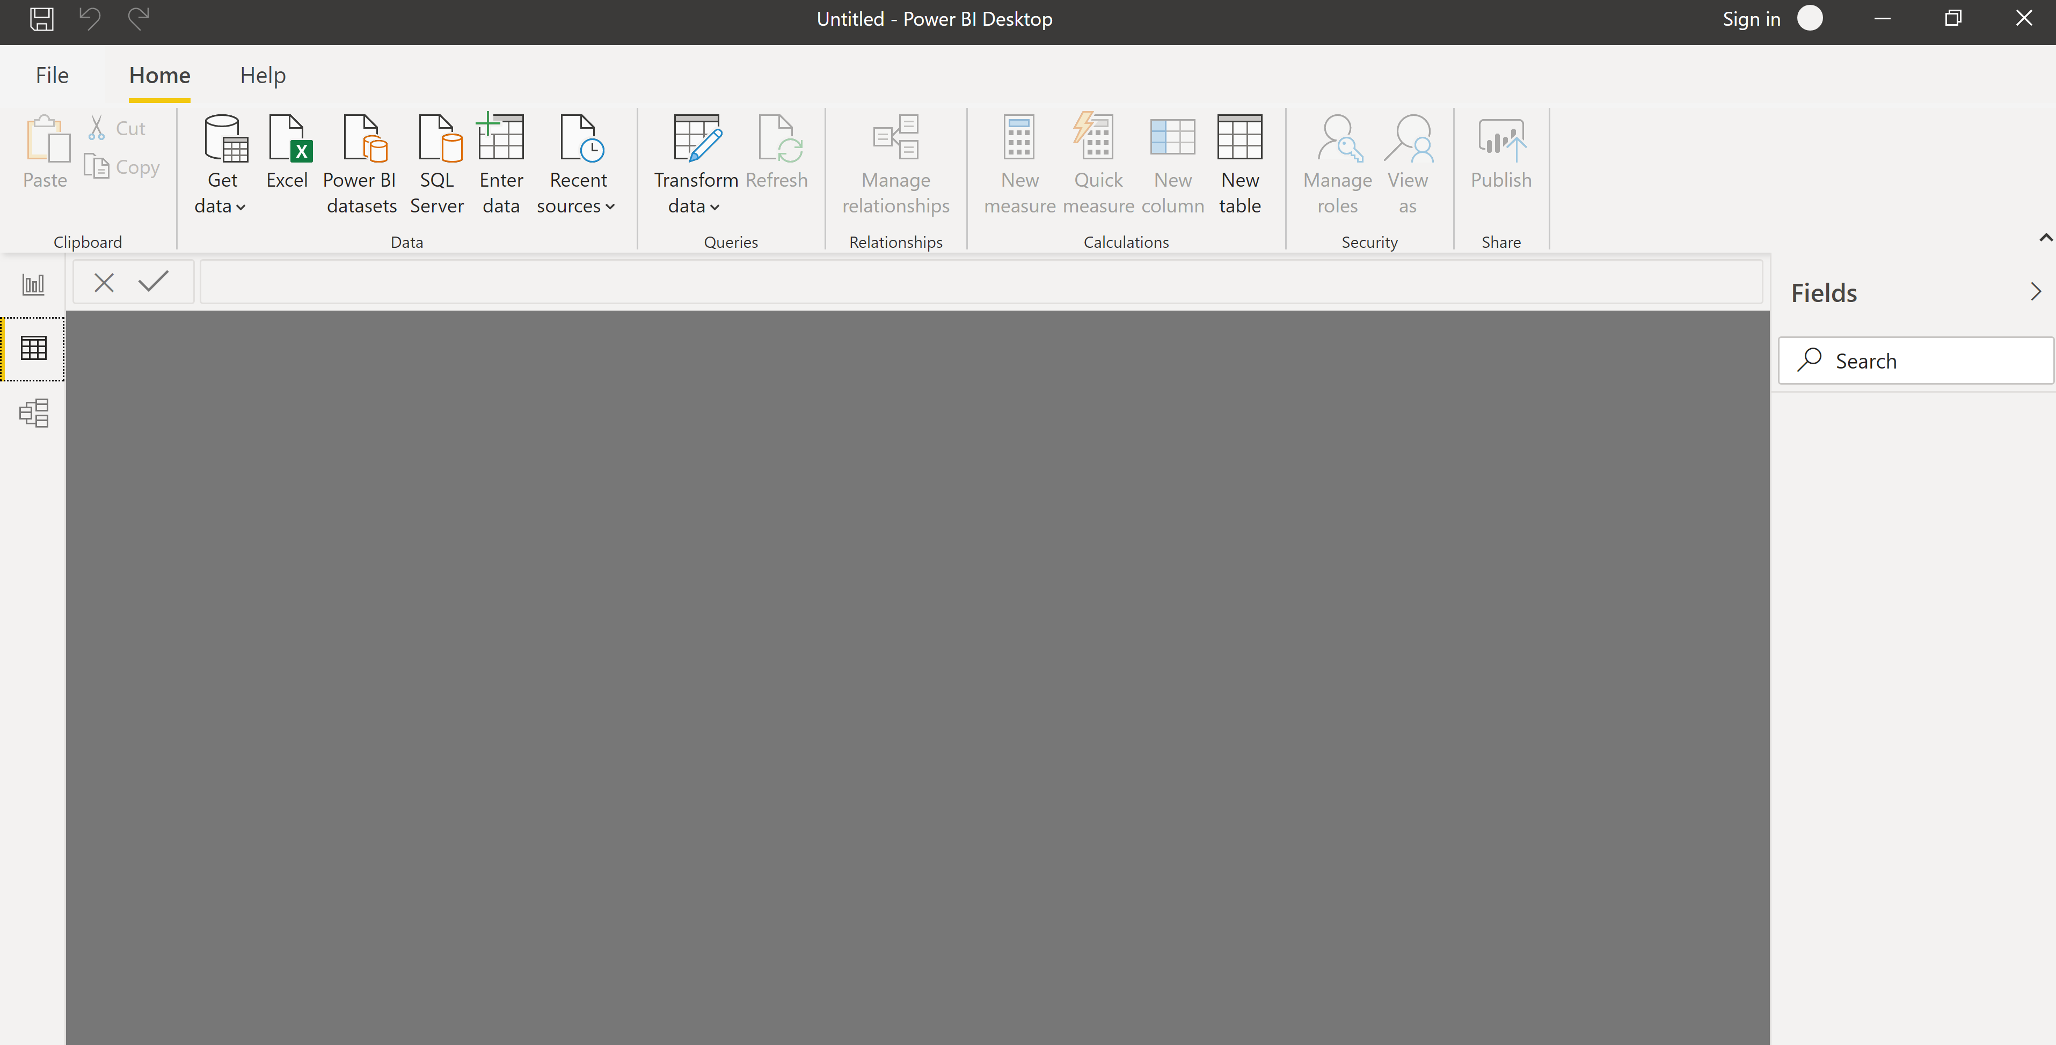

Model View:

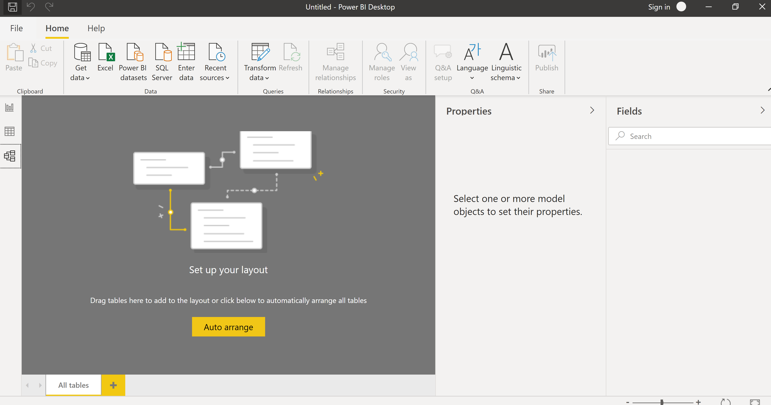

Power Query Editor:

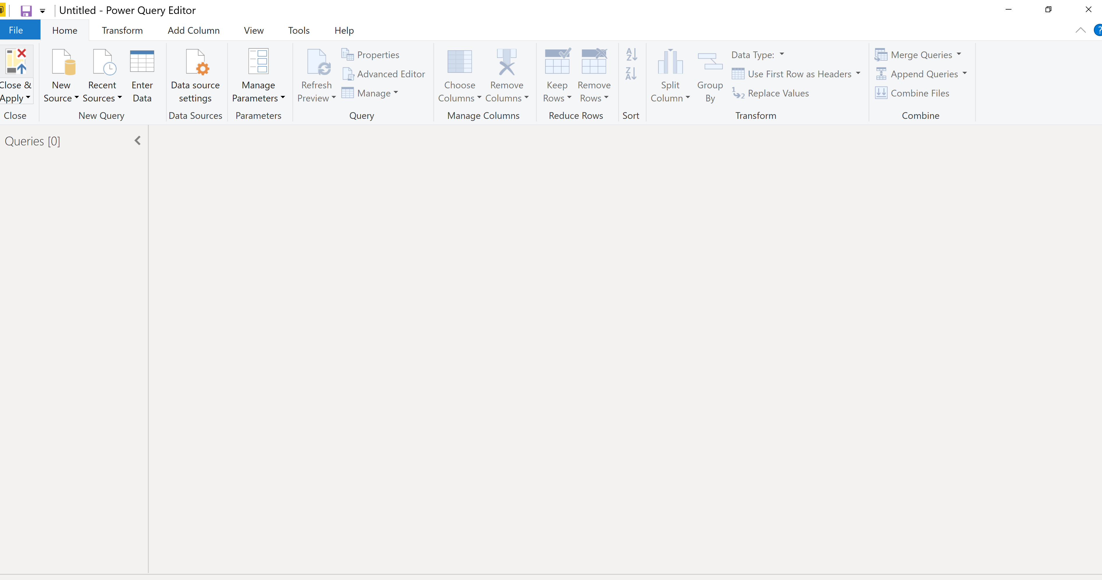

Advance Editor:

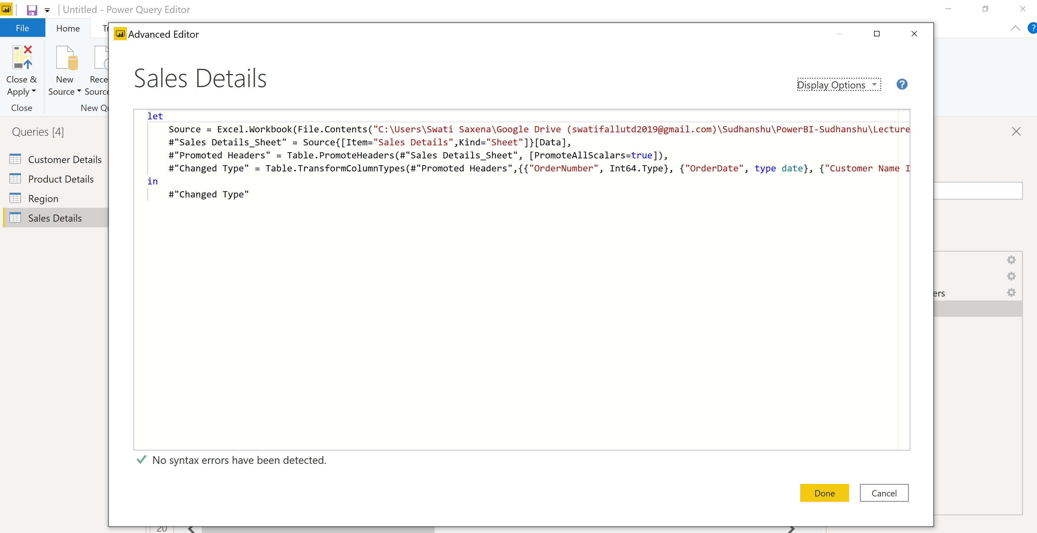

Part 3:

* Power BI Desktop:

**Power BI Desktop** lets you build advanced queries, models, and reports that visualize data. With **Power BI Desktop**, you can build data models, create reports, and share your work by publishing to the **Power BI** service. **Power BI Desktop** is a free download.

* Power BI Pro

**Power BI Pro** is an individual user license that lets users read and interact with reports and dashboards that others have published to the **Power BI** service. Users with this license type can share content and collaborate with other **Power BI Pro** users.

* Power BI Premium:

**Power BI Premium** is a capacity-based offering that includes: Flexibility to publish reports broadly across an enterprise, without requiring recipients to be licensed individually per user. Greater scale and performance than shared capacity in the **Power BI** service